**Assignment 4.3:**

**Steps:**

1. Create a text file with some words in it as below:

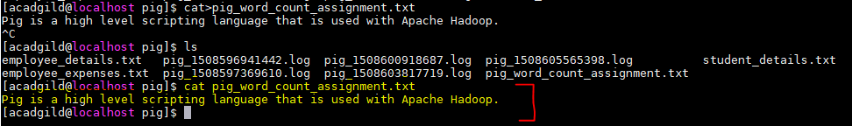

1. Load the data of txt file into a relation ‘lines’:

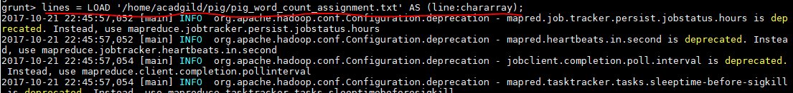

1. Load the lines into a relation ‘words’:

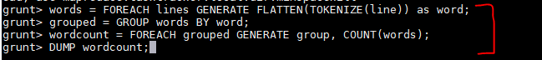

1. Final word count output:

